JAVA LAB PROGRAM 2

import java.util.Scanner;

class Student {

String name;

String USN;

int marks[];

int credits[];

int n;

void inputDetails() {

Scanner input = new Scanner(System.in);

System.out.print("Enter name: ");

name = input.nextLine();

System.out.print("Enter USN: ");

USN = input.nextLine();

System.out.println("Enter no. of subjects: ");

n = input.nextInt();

marks = new int[n];

credits = new int[n];

System.out.println("Enter marks: ");

for (int i = 0; i < n; i++) {

marks[i] = input.nextInt();

}

System.out.println("Enter credits: ");

for (int i = 0; i < n; i++) {

credits[i] = input.nextInt();

}

}

}

class Student {

String name;

String USN;

int marks[];

int credits[];

int n;

void displayDetails() {

System.out.println("Student Name: " + name);

System.out.println("Student USN: " + USN);

System.out.println("Marks Scored:");

for (int i = 0; i < marks.length; i++) {

System.out.println(marks[i]);

}

System.out.println("Credits for Subjects:");

for (int i = 0; i < credits.length; i++) {

System.out.println(credits[i]);

}

System.out.println("SGPA is: " + sgpaCalculation());

}

double sgpaCalculation() {

int total_sum = 0;

int sum_credits = 0;

for (int i = 0; i < n; i++) {

total_sum += marks[i] * credits[i];

sum_credits += credits[i];

}

return (double) total_sum / sum_credits * 100;

}

}

class Student {

String name;

String USN;

Student(String name, String USN) {

this.name = name;

this.USN = USN;

}

public static void main(String[] args) {

Student obj = new Student("Student Name", "Student USN");

obj.inputDetails();

obj.displayDetails();

}

}

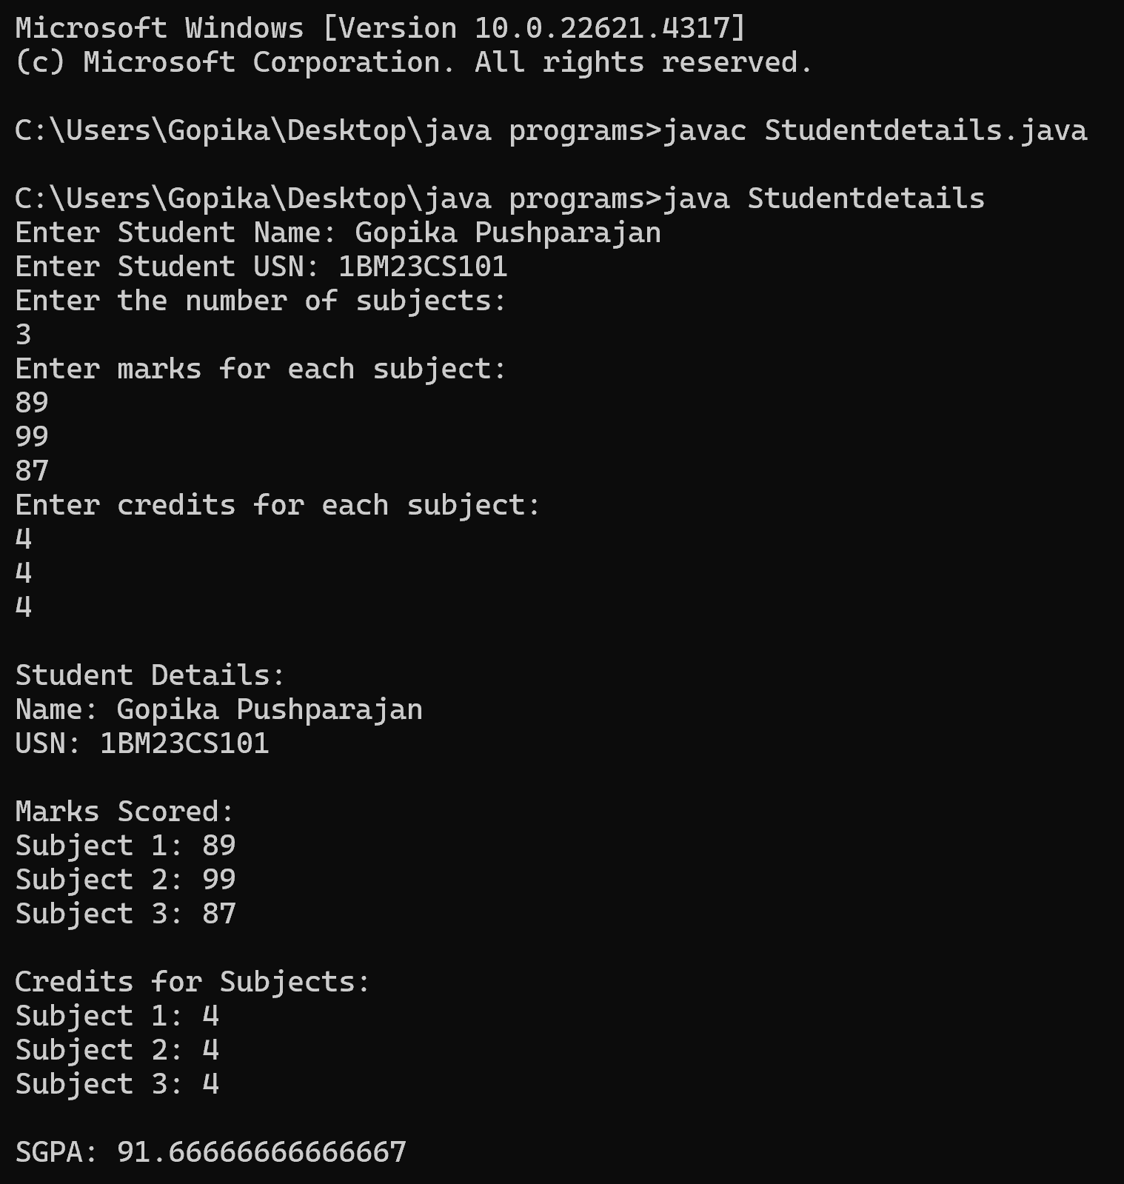OUTPUT